Grant Wright
Categorical Exclusions
Including FHWA 23 CFR 771.117, c and d

Summary: Applicability:
Categorical Exclusions (CEs) are actions (or projects) that do not have significant effect on the human environment per findings of a Federal agency. CEs are allowed exceptions from National Environmental Policy Act (NEPA) requirements including environmental assessments and environmental impact statements.

CEs are defined by the Council of Environmental Quality (CEQ) in 40 CFR § 1508.4 - Categorical exclusion, and Federal regulations that govern individual Federal agencies such as 23 C.F.R. 771.117 for the Federal Highway Administration (FHWA). 23 C.F.R. 771.117 (c) and (d) contain lists of activities that meet the CE criteria for the FHWA. The c list actions usually do not need supplemental documentation, d list actions will require additional documentation with a CE application.

Extraordinary circumstances will negate the use of a CE for an action, these may include impacts on wetlands, endangered species, and cultural sites.

Permit Name
Categorical Exclusions are referred to as CEs and Cat Exs. They exempt further investigation of environmental effects normally required of projects by NEPA. CEs are not permits, they are used to satisfy the NEPA procedures required of Federal Agencies.

APPLICABILITY
Nearly all projects with federal funding requires NEPA. Some may qualify for CEs.
For the FHWA 23 C.F.R. 771.117 c and d list actions may meet the CE criteria.
40 CFR § 1508.4 - Categorical exclusion.
Categorical exclusion means a category of actions which do not individually or cumulatively have a significant effect on the human environment and which have been found to have no such effect.

PROCESSING TIMES

Less than 60 months for sure (the median time for an EIS)
https://www.environment.fhwa.dot.gov/nepa/timeliness_of_nepa.aspx

Agency Coordination:
Lead Agency - FHWA, Department of Transportation and Public Facilities (DOT&PF) is a designated agency in Alaska. Per 23 USC 327 and a Memorandum of Understanding between FHWA and DOT&PF dated Nov. 3rd, 2017.

Complementary Roles of Other Public Agencies
A Federal Agency may not use CEs from other agency’s written procedures. CEs from other agencies may be used to prove that an action has no significant effect when amending the Federal Register for the interested agency to include the action as a CE.

Federal, State, and Local Government agencies may need to be consulted to determine impact on wildlife, floodplains, historic buildings etc. The AK DOT Cat Ex Documentation form lists many of these in the Comments and Coordination section

Key people: DOT CatEx form has signature spaces for Environmental Impact Analyst, Engineering Manager, and Regional Environmental Manager

AK DOT Statewide Environmental Office Document Prep
http://www.dot.state.ak.us/stwddes/desenviron/resources/docprep.shtml
AK DOT Categorical Exclusion Manual
http://www.dot.state.ak.us/stwddes/desenviron/assets/pdf/manual/ch03.pdf

AK DOT Doug - douglas.kolwaite@alaska.gov
Statewide Environmental Program Manager
3132 Channel Dr.,
P.O. Box 112500
Juneau, AK 99811-2500
Phone: (907) 465-2975
Fax: (907) 465-3124

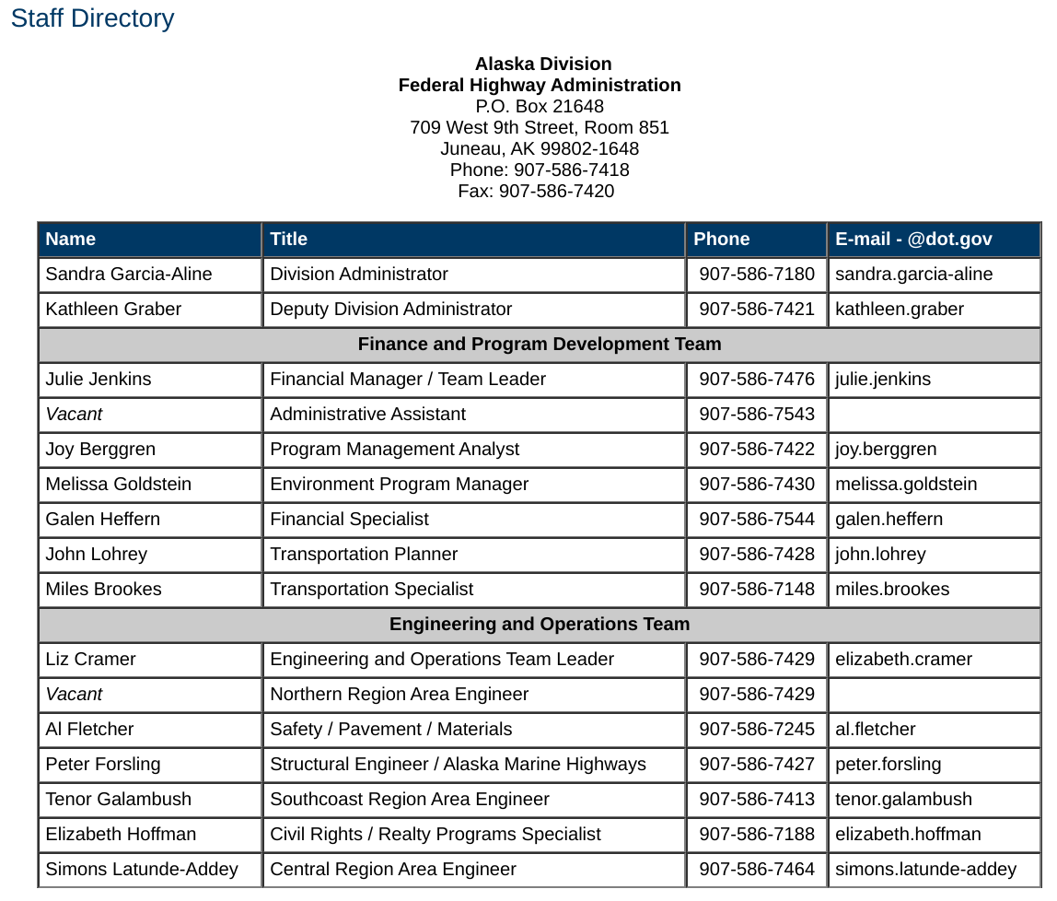
FHWA Alaska Division: https://www.fhwa.dot.gov/akdiv/

Information Necessary:
Documentation (from DOT CatEx Documentation Form:
Project Information
- Project Name
- Federal Project Number
- State Project Number
- Primary / Ancillary Project Connections
- CE Designation in 23 CFR 771.117
- Project Scope (STIP Project Description)
- Project Purpose and Need
- Project Description
Environmental Consequences
- Right of Way Impacts
- Social and Cultural Impacts
- Economic Impacts
- Land Use and Transportation Plans
- Impacts to Historic Properties
- Wetland Impacts
- Water Body Involvement
- Fish & Wildlife
- Threatened & Endangered Species
- Invasive Species
- Contaminated Sites
- Air Quality
- Floodplain Impacts
- Noise Impacts
- Water Quality Impacts
- Construction Impacts
- Section 4(f)/6(f) 23 CFR 774
Permits and Authorizations
- USACE
- Coast Guard
- ADF&G Fish Habitat
- Flood Hazard
- ADEC Non-Domestic Wastewater Plan
- ADEC 401
- ADEC APDES
- Noise
- Eagle Permit
- Others
Comments and Coordination
- Public/Agency involvement
- Public meetings
- Public notifications
- Agency meetings
Environmental Commitments and Mitigation Measures - Summary

Special definitions
CE – Categorical Exclusion
CEQ – Council on Environmental Quality
CFR – Code of Federal Regulations
DOT&PF – Department of Transportation & Public Facilities
EA – Environmental Assessment
EIS – Environmental Impact Statement
FHWA – Federal Highway Administration
MOU – Memorandum of Understanding
NEPA – National Environmental Policy Act
QA/QC – Quality Assurance/Quality Control
REM – Regional Environmental Manager
USC – United States Code

Enforcement and Penalties:
Lawsuits, Project Delay, Denial of Funding, Negative Perception
https://www.fema.gov/possible-consequences-not-following-national-environmental-policy-act-process

Other Resources
FHWA Classes of Action Page
https://www.environment.fhwa.dot.gov/nepa/classes_of_action.aspx

US DOT FHWA Categorical Exclusion Video (6 min)
https://www.youtube.com/watch?v=-Bx973AEe0k

US DOT NEPA Categorical Exclusion Survey Review - 2012
https://www.environment.fhwa.dot.gov/nepa/sec1318report.pdf

CEQ Memorandum on Revising Categorical Exclusion under NEPA
https://ceq.doe.gov/docs/ceq-regulations-and-guidance/NEPA_CE_Guidance_Nov232010.pdf

AK DOT Categorical Exclusion Manual
http://www.dot.state.ak.us/stwddes/desenviron/assets/pdf/manual/ch03.pdf

AK DOT Statewide Environmental Office
http://www.dot.state.ak.us/stwddes/desenviron/index.shtml

AK DOT NEPA Assignment and CE Assignment
http://www.dot.state.ak.us/stwddes/desenviron/resources/nepa.shtml

AK DOT Statewide Environmental Office Document Prep
http://www.dot.state.ak.us/stwddes/desenviron/resources/docprep.shtml

REGULATIONS (CFR)
State
Alaska has best practices but no statewide NEPA style regulation. The State DOT&PF has assumed responsibility for NEPA review from the FHWA since 2017. The State DOT makes determinations and approves CEs for FHWA projects.

Federal
https://www.law.cornell.edu/cfr/text/40/1508.4
40 CFR 1508.4 - Categorical exclusion.
Categorical exclusion means a category of actions which do not individually or cumulatively have a significant effect on the human environment and which have been found to have no such effect in procedures adopted by a Federal agency in implementation of these regulations (§ 1507.3) and for which, therefore, neither an environmental assessment nor an environmental impact statement is required. An agency may decide in its procedures or otherwise, to prepare environmental assessments for the reasons stated in § 1508.9 even though it is not required to do so. Any procedures under this section shall provide for extraordinary circumstances in which a normally excluded action may have a significant environmental effect.

https://www.law.cornell.edu/cfr/text/23/771.117
23 CFR § 771.117 - FHWA categorical exclusions.
(a) CEs are actions that meet the definition contained in 40 CFR 1508.4, and, based on FHWA's past experience with similar actions, do not involve significant environmental impacts. They are actions that: Do not induce significant impacts to planned growth or land use for the area; do not require the relocation of significant numbers of people; do not have a significant impact on any natural, cultural, recreational, historic or other resource; do not involve significant air, noise, or water quality impacts; do not have significant impacts on travel patterns; or do not otherwise, either individually or cumulatively, have any significant environmental impacts.

(c) and (d) list current FHWA CEs approved for use.

(c) The following actions meet the criteria for CEs in the CEQ regulations (40 CFR 1508.4) and paragraph (a) of this section and normally do not require any further NEPA approvals by the FHWA:
(1) Activities that do not involve or lead directly to construction, such as planning and research activities; grants for training; engineering to define the elements of a proposed action or alternatives so that social, economic, and environmental effects can be assessed; and Federal-aid system revisions that establish classes of highways on the Federal-aid highway system.
(2) Approval of utility installations along or across a transportation facility.
(3) Construction of bicycle and pedestrian lanes, paths, and facilities.
(4) Activities included in the State's highway safety plan under 23 U.S.C. 402.
(5) Transfer of Federal lands pursuant to 23 U.S.C. 107(d) and/or 23 U.S.C. 317 when the land transfer is in support of an action that is not otherwise subject to FHWA review under NEPA.
(6) The installation of noise barriers or alterations to existing publicly owned buildings to provide for noise reduction.
(7) Landscaping.
(8) Installation of fencing, signs, pavement markings, small passenger shelters, traffic signals, and railroad warning devices where no substantial land acquisition or traffic disruption will occur.
(9) The following actions for transportation facilities damaged by an incident resulting in an emergency declared by the Governor of the State and concurred in by the Secretary, or a disaster or emergency declared by the President pursuant to the Robert T. Stafford Act (42 U.S.C. 5121):
(i) Emergency repairs under 23 U.S.C. 125; and
(ii) The repair, reconstruction, restoration, retrofitting, or replacement of any road, highway, bridge, tunnel, or transit facility (such as a ferry dock or bus transfer station), including ancillary transportation facilities (such as pedestrian/bicycle paths and bike lanes), that is in operation or under construction when damaged and the action:
(A) Occurs within the existing right-of-way and in a manner that substantially conforms to the preexisting design, function, and location as the original (which may include upgrades to meet existing codes and standards as well as upgrades warranted to address conditions that have changed since the original construction); and
(B) Is commenced within a 2-year period beginning on the date of the declaration.
(10) Acquisition of scenic easements.
(11) Determination of payback under 23 U.S.C. 156 for property previously acquired with Federal-aid participation.
(12) Improvements to existing rest areas and truck weigh stations.
(13) Ridesharing activities.
(14) Bus and rail car rehabilitation.
(15) Alterations to facilities or vehicles in order to make them accessible for elderly and handicapped persons.
(16) Program administration, technical assistance activities, and operating assistance to transit authorities to continue existing service or increase service to meet routine changes in demand.
(17) The purchase of vehicles by the applicant where the use of these vehicles can be accommodated by existing facilities or by new facilities that themselves are within a CE.
(18) Track and railbed maintenance and improvements when carried out within the existing right-of-way.
(19) Purchase and installation of operating or maintenance equipment to be located within the transit facility and with no significant impacts off the site.
(20) Promulgation of rules, regulations, and directives.
(21) Deployment of electronics, photonics, communications, or information processing used singly or in combination, or as components of a fully integrated system, to improve the efficiency or safety of a surface transportation system or to enhance security or passenger convenience. Examples include, but are not limited to, traffic control and detector devices, lane management systems, electronic payment equipment, automatic vehicle locaters, automated passenger counters, computer-aided dispatching systems, radio communications systems, dynamic message signs, and security equipment including surveillance and detection cameras on roadways and in transit facilities and on buses.
(22) Projects, as defined in 23 U.S.C. 101, that would take place entirely within the existing operational right-of-way. Existing operational right-of-way means all real property interests acquired for the construction, operation, or mitigation of a project. This area includes the features associated with the physical footprint of the project including but not limited to the roadway, bridges, interchanges, culverts, drainage, clear zone, traffic control signage, landscaping, and any rest areas with direct access to a controlled access highway. This also includes fixed guideways, mitigation areas, areas maintained or used for safety and security of a transportation facility, parking facilities with direct access to an existing transportation facility, transportation power substations, transportation venting structures, and transportation maintenance facilities.
(23) Federally funded projects:
(i) That receive less than $5,000,000 (as adjusted annually by the Secretary to reflect any increases in the Consumer Price Index prepared by the Department of Labor, see www.fhwa.dot.gov or www.fta.dot.gov) of Federal funds; or
(ii) With a total estimated cost of not more than $30,000,000 (as adjusted annually by the Secretary to reflect any increases in the Consumer Price Index prepared by the Department of Labor, see www.fhwa.dot.gov or www.fta.dot.gov) and Federal funds comprising less than 15 percent of the total estimated project cost.
(24) Localized geotechnical and other investigation to provide information for preliminary design and for environmental analyses and permitting purposes, such as drilling test bores for soil sampling; archeological investigations for archeology resources assessment or similar survey; and wetland surveys.
(25) Environmental restoration and pollution abatement actions to minimize or mitigate the impacts of any existing transportation facility (including retrofitting and construction of stormwater treatment systems to meet Federal and State requirements under sections 401 and 402 of the Federal Water Pollution Control Act (33 U.S.C. 1341; 1342)) carried out to address water pollution or environmental degradation.
(26) Modernization of a highway by resurfacing, restoration, rehabilitation, reconstruction, adding shoulders, or adding auxiliary lanes (including parking, weaving, turning, and climbing lanes), if the action meets the constraints in paragraph (e) of this section.
(27) Highway safety or traffic operations improvement projects, including the installation of ramp metering control devices and lighting, if the project meets the constraints in paragraph (e) of this section.
(28) Bridge rehabilitation, reconstruction, or replacement or the construction of grade separation to replace existing at-grade railroad crossings, if the actions meet the constraints in paragraph (e) of this section.
(29) Purchase, construction, replacement, or rehabilitation of ferry vessels (including improvements to ferry vessel safety, navigation, and security systems) that would not require a change in the function of the ferry terminals and can be accommodated by existing facilities or by new facilities that themselves are within a CE.
(30) Rehabilitation or reconstruction of existing ferry facilities that occupy substantially the same geographic footprint, do not result in a change in their functional use, and do not result in a substantial increase in the existing facility's capacity. Example actions include work on pedestrian and vehicle transfer structures and associated utilities, buildings, and terminals.
(d) Additional actions that meet the criteria for a CE in the CEQ regulations (40 CFR 1508.4) and paragraph (a) of this section may be designated as CEs only after Administration approval unless otherwise authorized under an executed agreement pursuant to paragraph (g) of this section. The applicant must submit documentation that demonstrates that the specific conditions or criteria for these CEs are satisfied, and that significant environmental effects will not result. Examples of such actions include but are not limited to:
(1)-(3) [Reserved]
(4) Transportation corridor fringe parking facilities.
(5) Construction of new truck weigh stations or rest areas.
(6) Approvals for disposal of excess right-of-way or for joint or limited use of right-of-way, where the proposed use does not have significant adverse impacts.
(7) Approvals for changes in access control.
(8) Construction of new bus storage and maintenance facilities in areas used predominantly for industrial or transportation purposes where such construction is not inconsistent with existing zoning and located on or near a street with adequate capacity to handle anticipated bus and support vehicle traffic.
(9) Rehabilitation or reconstruction of existing rail and bus buildings and ancillary facilities where only minor amounts of additional land are required, and there is not a substantial increase in the number of users.
(10) Construction of bus transfer facilities (an open area consisting of passenger shelters, boarding areas, kiosks and related street improvements) when located in a commercial area or other high activity center in which there is adequate street capacity for projected bus traffic.
(11) Construction of rail storage and maintenance facilities in areas used predominantly for industrial or transportation purposes where such construction is not inconsistent with existing zoning, and where there is no significant noise impact on the surrounding community.
(12) Acquisition of land for hardship or protective purposes. Hardship and protective buying will be permitted only for a particular parcel or a limited number of parcels. These types of land acquisition qualify for a CE only where the acquisition will not limit the evaluation of alternatives, including shifts in alignment for planned construction projects, which may be required in the NEPA process. No project development on such land may proceed until the NEPA process has been completed.
(i) Hardship acquisition is early acquisition of property by the applicant at the property owner's request to alleviate particular hardship to the owner, in contrast to others, because of an inability to sell his property. This is justified when the property owner can document on the basis of health, safety or financial reasons that remaining in the property poses an undue hardship compared to others.
(ii) Protective acquisition is done to prevent imminent development of a parcel that may be needed for a proposed transportation corridor or site. Documentation must clearly demonstrate that development of the land would preclude future transportation use and that such development is imminent. Advance acquisition is not permitted for the sole purpose of reducing the cost of property for a proposed project.
(13) Actions described in paragraphs (c)(26), (c)(27), and (c)(28) of this section that do not meet the constraints in paragraph (e) of this section.

